November 2016

Introducing Renishaw’s new RA802 Pharmaceutical Analyser
The new RA802 Pharmaceutical Analyser is a compact benchtop Raman imaging system, designed exclusively for the pharmaceutical industry. This easy-to-use instrument redefines how Raman spectroscopy is used for formulation analysis.
The RA802 enables users to formulate tablets more efficiently by speeding up the analysis of tablet composition and structure. It brings together the chemical analysis power of Raman spectroscopy and advanced imaging technologies in a powerful, robust system. Users can reveal detailed chemical and physical information about the contents of their sample, from the distribution and size of API domains to the physical topography. The RA802 makes the highest performance Raman spectroscopy accessible to all users.
The system uses Renishaw’s latest innovation, LiveTrack focus-tracking technology, to enable users to analyse samples with uneven, curved or rough surfaces at incredible speeds without requiring any sample preparation. Intact tablets can be analysed, or they can be split or sliced to reveal their internal structures. LiveTrack continuously adjusts the sample’s height, producing information-rich three dimensional chemical maps of a tablet’s surface.
Tim Smith, Head of Applications, said: “The RA802 makes the Raman analysis of tablets, powders, granules, liquids and sprays simple. Users can obtain detailed information about the distribution of chemical species faster with the simplest sample preparation. It provides users with a practical solution for analysing formulations and gives great results without complexity.”
Renishaw’s Raman systems are trusted worldwide to deliver outstanding performance and reliable results. The RA802 has the functionality and validation needed to meet the specific challenges of pharmaceutical formulation analysis, without compromise.
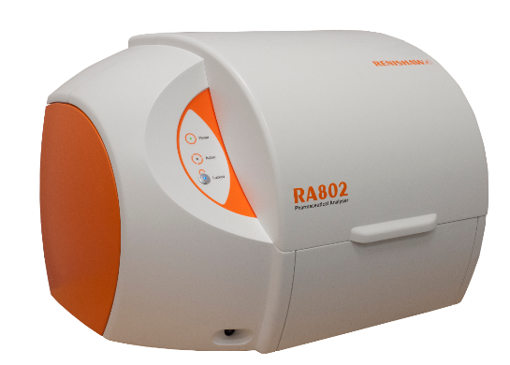
See the RA802 at AAPS in Denver on booth 551 or visit www.renishaw.com/802
Image: Renishaw’s RA802 Pharmaceutical Analyser.
-ENDS-

About Renishaw
Renishaw is one of the world's leading engineering and scientific technology companies, with expertise in precision measurement and healthcare. The company supplies products and services used in applications as diverse as jet engine and wind turbine manufacture, through to dentistry and brain surgery. It is also a world leader in the field of additive manufacturing (also referred to as 3D printing), where it is the only UK business that designs and makes industrial machines which ‘print' parts from metal powder.
The Renishaw Group currently has more than 70 offices in 35 countries, with over 4,000 employees, of which 2,700 people are employed within the UK. The majority of the company's R&D and manufacturing is carried out in the UK and for the year ended June 2016 Renishaw achieved sales of £436.6 million of which 95% was due to exports. The company's largest markets are the China, USA, Germany and Japan.
The Company's success has been recognised with numerous international awards, including eighteen Queen's Awards recognising achievements in technology, export and innovation. Renishaw received a Queen’s Award for Enterprise 2014, in the Innovations category, for the continuous development of the inVia confocal Raman microscope. For more information, visit www.renishaw.com

For further information
Please contact:
David Reece
Renishaw plc
New Mills
Wotton-under-Edge
Gloucestershire GL12 8JR UK
Tel: +44 1453 523968 (direct)
Tel: +44 1453 524524 (switchboard)
Fax: +44 1453 523901
Email: david.reece@renishaw.com
www.renishaw.com/raman

